***dt : 30/9/2022***

***single Inheritance Models:***

***Diagram:***

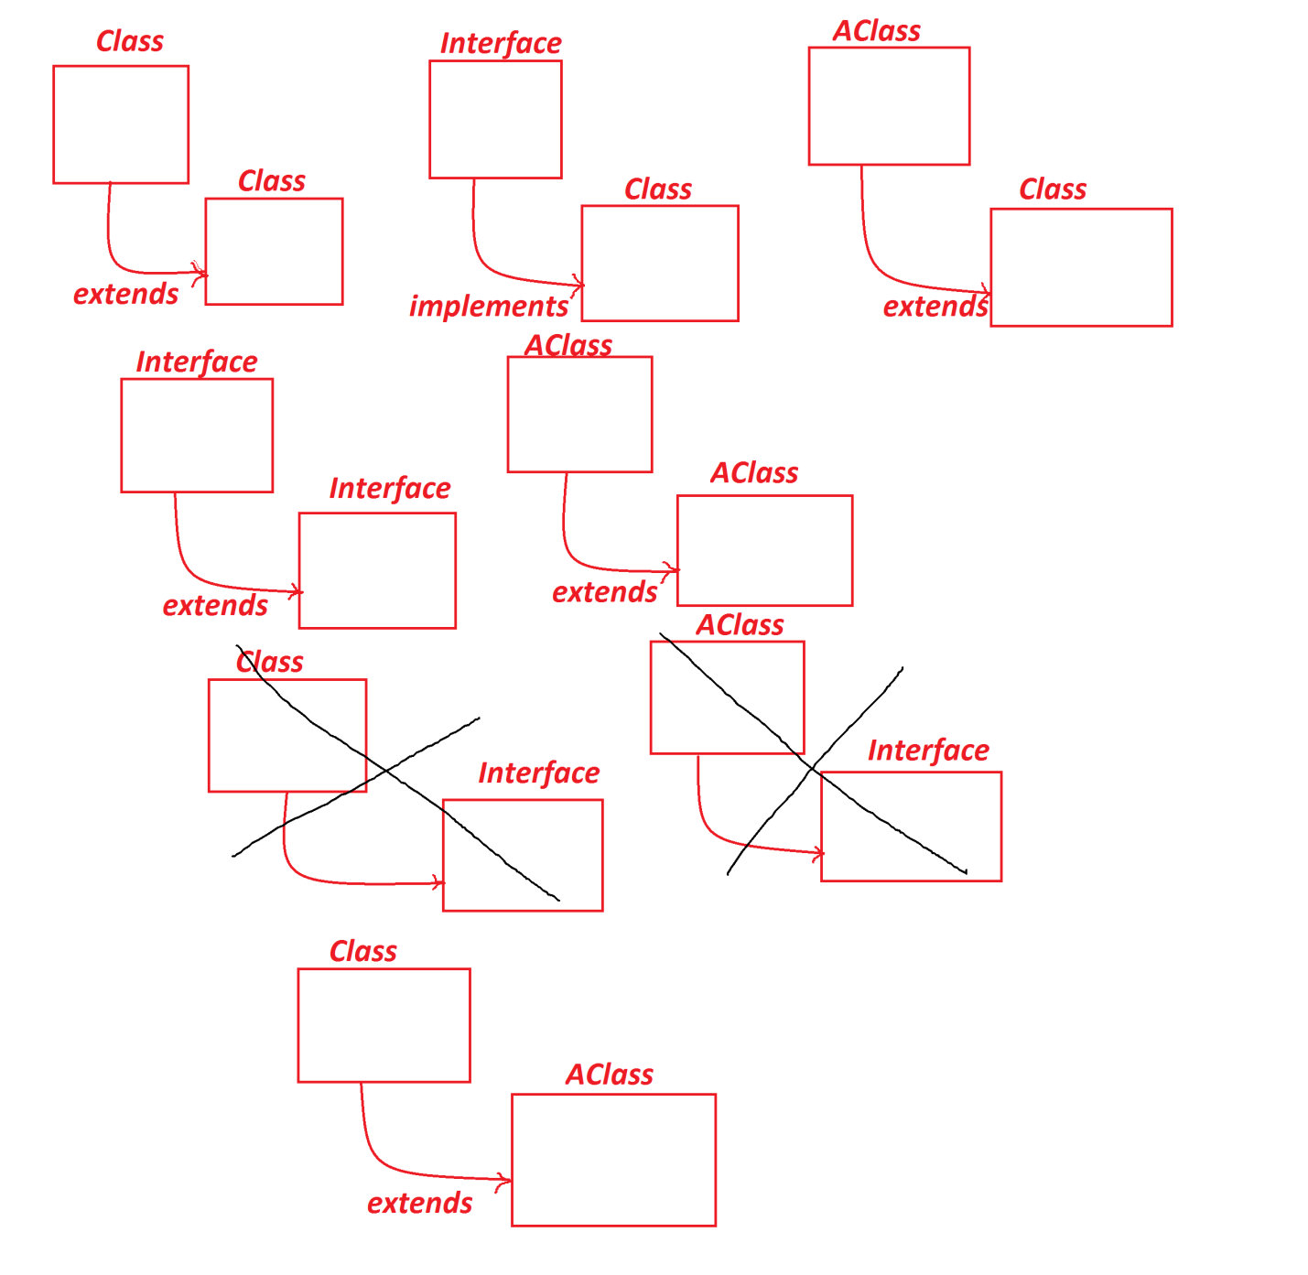

***=============================================================***

***faq:***

***wt is the diff b/w***

***(i)HAS-A relation***

***(ii)IS-A relation***

***(i)HAS-A relation:***

***=>references concept is known as HAS-A relation,because one***

***Object HAS-A reference of another Object.***

***(ii)IS-A relation:***

***=>Inheritance process is known as IS-A relation.***

***=============================================================***

***faq:***

***define abstraction process?***

***=>The process of hiding non-essential things and showing only***

***essential things to the user(EndUser) is known as abstraction***

***process.***

***=>we perform abstraction process using "Interfaces" and***

***"abstract classes"***

***=============================================================***

***faq:***

***define abstract components?***

***=>The components which are not having any physical existence are***

***known as abstract components.***

***===============================================================***

***faq:***

***define Encapsulation process?***

***=>The process of binding all the programming components into a***

***Single unit "class" is known as Encapsulation process.***

***===========================================================***

***\*imp***

***InnerClasses in Java:***

***=>The process of declaring the class inside the class is known as***

***InnerClass or Nested Class.***

***=>InnerClasses are categorized into two types:***

***1.Member InnerClasses***

***2.Anonymous InnerClasses***

***1.Member InnerClasses:***

***=>The classes which are declared as members of class are known as***

***Member InnerClasses.***

***=>These member InnerClasses are categorized into two types:***

***(a)Static member InnerClasses***

***(b)Non-Static member InnerClasses***

***(a)Static member InnerClasses:***

***=>The member InnerClasses which are declared with "static"***

***keyword outside the methods are known as Static member InnerClasses***

***or Class member InnerClasses.***

***Coding Rules:***

***(i)Static member InnerClasses can be declared with both static***

***and NonStatic members.***

***(ii)The instance method of Static member InnerClass will have***

***behaviour like static method and access only static members of***

***OuterClass.***

***(iii)The static method of Static member InnerClass can access***

***only static members of OuterClass.***

***=>Object creation for Static member InnerClasses:***

***OuterClass_name.InnerClass_name obj =***

***new OuterClass_name.InnerClass_name();***

***Ex:***

***SubClass1.SubClass2 ob2 = new SubClass1.SubClass2();***

***SubClass1.java***

***package test;***

***public class SubClass1 {***

***public int a=10;***

***public static int b=20;***

***public void m1() {***

***System.out.println("***OterClass method m1()***");***

***System.out.println("a:"+a);***

***System.out.println("b:"+b);***

***}//OuterClass method***

***public static class SubClass2{***

***public void m2() {***

***System.out.println("***InnerClass Instance m2()***");***

***//System.out.println("a:"+a);***

***System.out.println("b:"+b);***

***}***

***public static void m22() {***

***System.out.println("***InnerClass static m22()***");***

***//System.out.println("a:"+a);***

***System.out.println("b:"+b);***

***}***

***}//Static member InnerClass***

***}//OuterClass***

***DemoInnerClass1.java(MainClass)***

***package maccess;***

***import test.SubClass1;***

***public class DemoInnerClass1 {***

***public static void main(String[] args) {***

***SubClass1 ob1 = new SubClass1();//OuterClass object***

***ob1.m1();//OuterClass method call***

***SubClass1.SubClass2 ob2 = new SubClass1.SubClass2();***

***//Static member InnerClass object***

***ob2.m2();//InnerClass_Instance_method_call***

***SubClass1.SubClass2.m22();//InnerClass_static_method_call***

***}***

***}***

***o/p:***

***\*\*\*OterClass method m1()\*\*\****

***a:10***

***b:20***

***\*\*\*InnerClass Instance m2()\*\*\****

***b:20***

***\*\*\*InnerClass static m22()\*\*\****

***b:20***

***------------------------------------------------------------------***

***Dt : 1/10/2022***

***Execution flow of above program:***

***ClassFiles:***

***SubClass1.class***

***DemoInnerClass1.class(MainClass)***

***SubClass1$SubClass2.class***

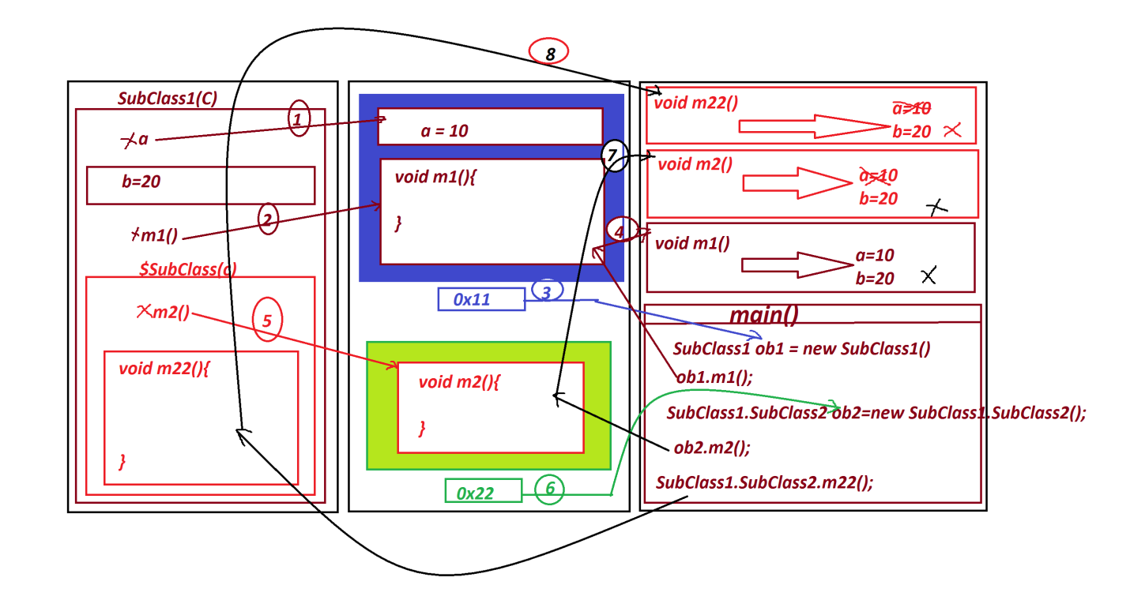

***---------------------------------------------------------------***

***Note:***

***=>Static member InnerClasses will get the memory within the***

***OuterClass and available in OuterClasses.***

***=============================================================***

***(b)Non-Static member InnerClasses:***

***=>The Member InnerClasses which are declared without 'static'***

***keyword are known as NonStatic member InnerClasses.***

***=>These Non-static member InnerClasses are categorized into two***

***types:***

***(i)Instance member InnerClasses***

***(ii)Local member InnerClasses***